# **Assignment 3 - Spark Data Frames and Clustering**

## Question 1. Find the title, year and director of action films that won an award.

### Output:



## Question 2. For each award-winning actor, find the movies he acted it. Print the names of the movies and the director of the movie.

### Output:

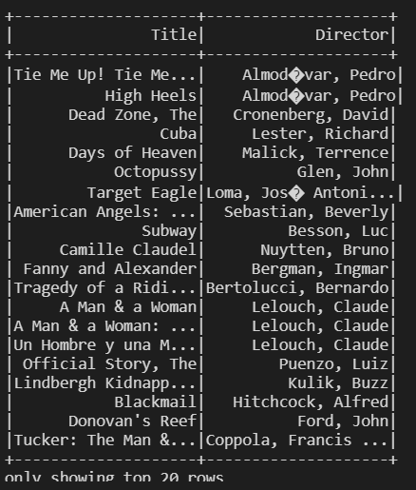

## Question 3. Find the top 10 most popular movies that did not win an award.

### Output:

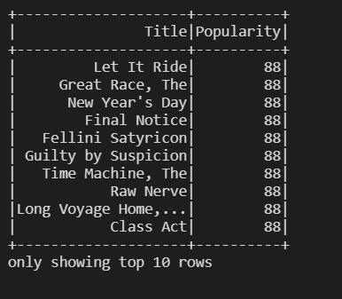

## Question 4. Find the 10 least popular movies that were released before 1980.

### Output:

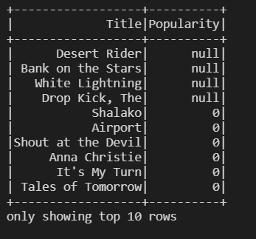

## Question 5. Find the average length of the movies of each genre.

### Output:

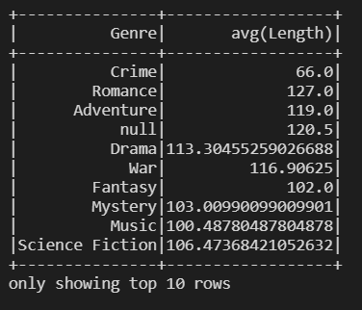

## Question 6. Find the actor and actress pair who have acted in more than three Comedies together.

### Output:

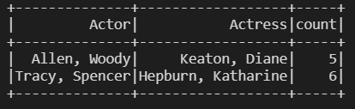

## Question 7. Find the names of actors who acted in movies of both ‘Comedy’ **and** ‘Drama’ Genre.

### Output:

### 

## Question 8. Find the names of actors who acted in movies of both ‘Comedy’ or ‘Drama’ Genre.

### Output:

### 

## Question 9. Find the names of actors who did not acted in any ‘Comedy’.

### Output:

### 

## Question 10. Find each actor, find the mean, max, min ranking of his movies.

### Output: s

## Question 11. List the number of movies released in each decade starting from 1960’s.

### Output:

### 

## Question 12. Find the number of movies released in each year.

### Output:

### 

## Question 13. Find the number of movies released in each year of each genre. Consider only the movies with length greater than 100 minutes.

### Output:

### 

## Question 14. Sort the movie’s release before 1990 by the title.

### Output:

### 

## Question 15. Find the movies with long titles. A movie title is considered long if it is greater than 50 alphabets.

### Output:

### 